Номинация: Вольная номинация
Автор: Ольга Николаевна Стогниева, Доцент Школы иностранных языков НИУ ВШЭ, Москва, stognieva@hse.ru
Дисциплина и ОП: Академическое письмо на английском языке; Образовательная программа: Бизнес-информатика

Искусство написания академического параграфа:
Пошаговое руководство
Введение

Обучение написанию академического параграфа (academic paragraph) является важным фактором для повышения эффективности письменной коммуникации в академической среде. Во-первых, понимание структуры параграфа способствует систематизации идей студентов, что приводит к развитию единого и связного аргумента в каждом параграфе. Во-вторых, правильное структурирование абзацев способствует эффективной организации информации и интеграции отдельных пунктов академической работы в единое целое, что значительно улучшает восприятие текста и способствует пониманию логики автора. Кроме того, овладение искусством написания академического параграфа является основой для развития углубленных навыков письма, позволяя студентам создавать более сложные тексты, такие как исследовательские работы и научные статьи, где представление аргументации и доказательств, логическая организация и связанность контента имеют ключевое значение. В целом, обучение написанию параграфа способствует развитию навыков письменной коммуникации, необходимых для участия в научной дискуссии.

Mastering the Art of Writing an Academic Paragraph:
A Step-by-step Guide

Goal: By the end of this module, students will have developed a strong understanding of the essential components of an academic paragraph, including structure, topic development, cohesion, in-text referencing, and expressing the author’s stance. They will also apply this knowledge by writing their own academic paragraphs, providing and receiving peer feedback to enhance clarity and coherence.
This goal emphasizes both the learning outcome (understanding academic paragraph elements) and the practical application (writing and peer feedback).
Level: B2-C1

Step I.
Basic Paragraph Analysis

Teacher | Hello, and welcome to this lesson on how to write an academic paragraph. Before we start, I’d like to state: there is no one way to write a paragraph. However, this lesson will help students new to academic writing identify the key components of a paragraph. We are going to discuss key areas of paragraph writing: basic paragraph structure, topic sentence, in-text referencing, cohesion, and the author’s stance or voice.  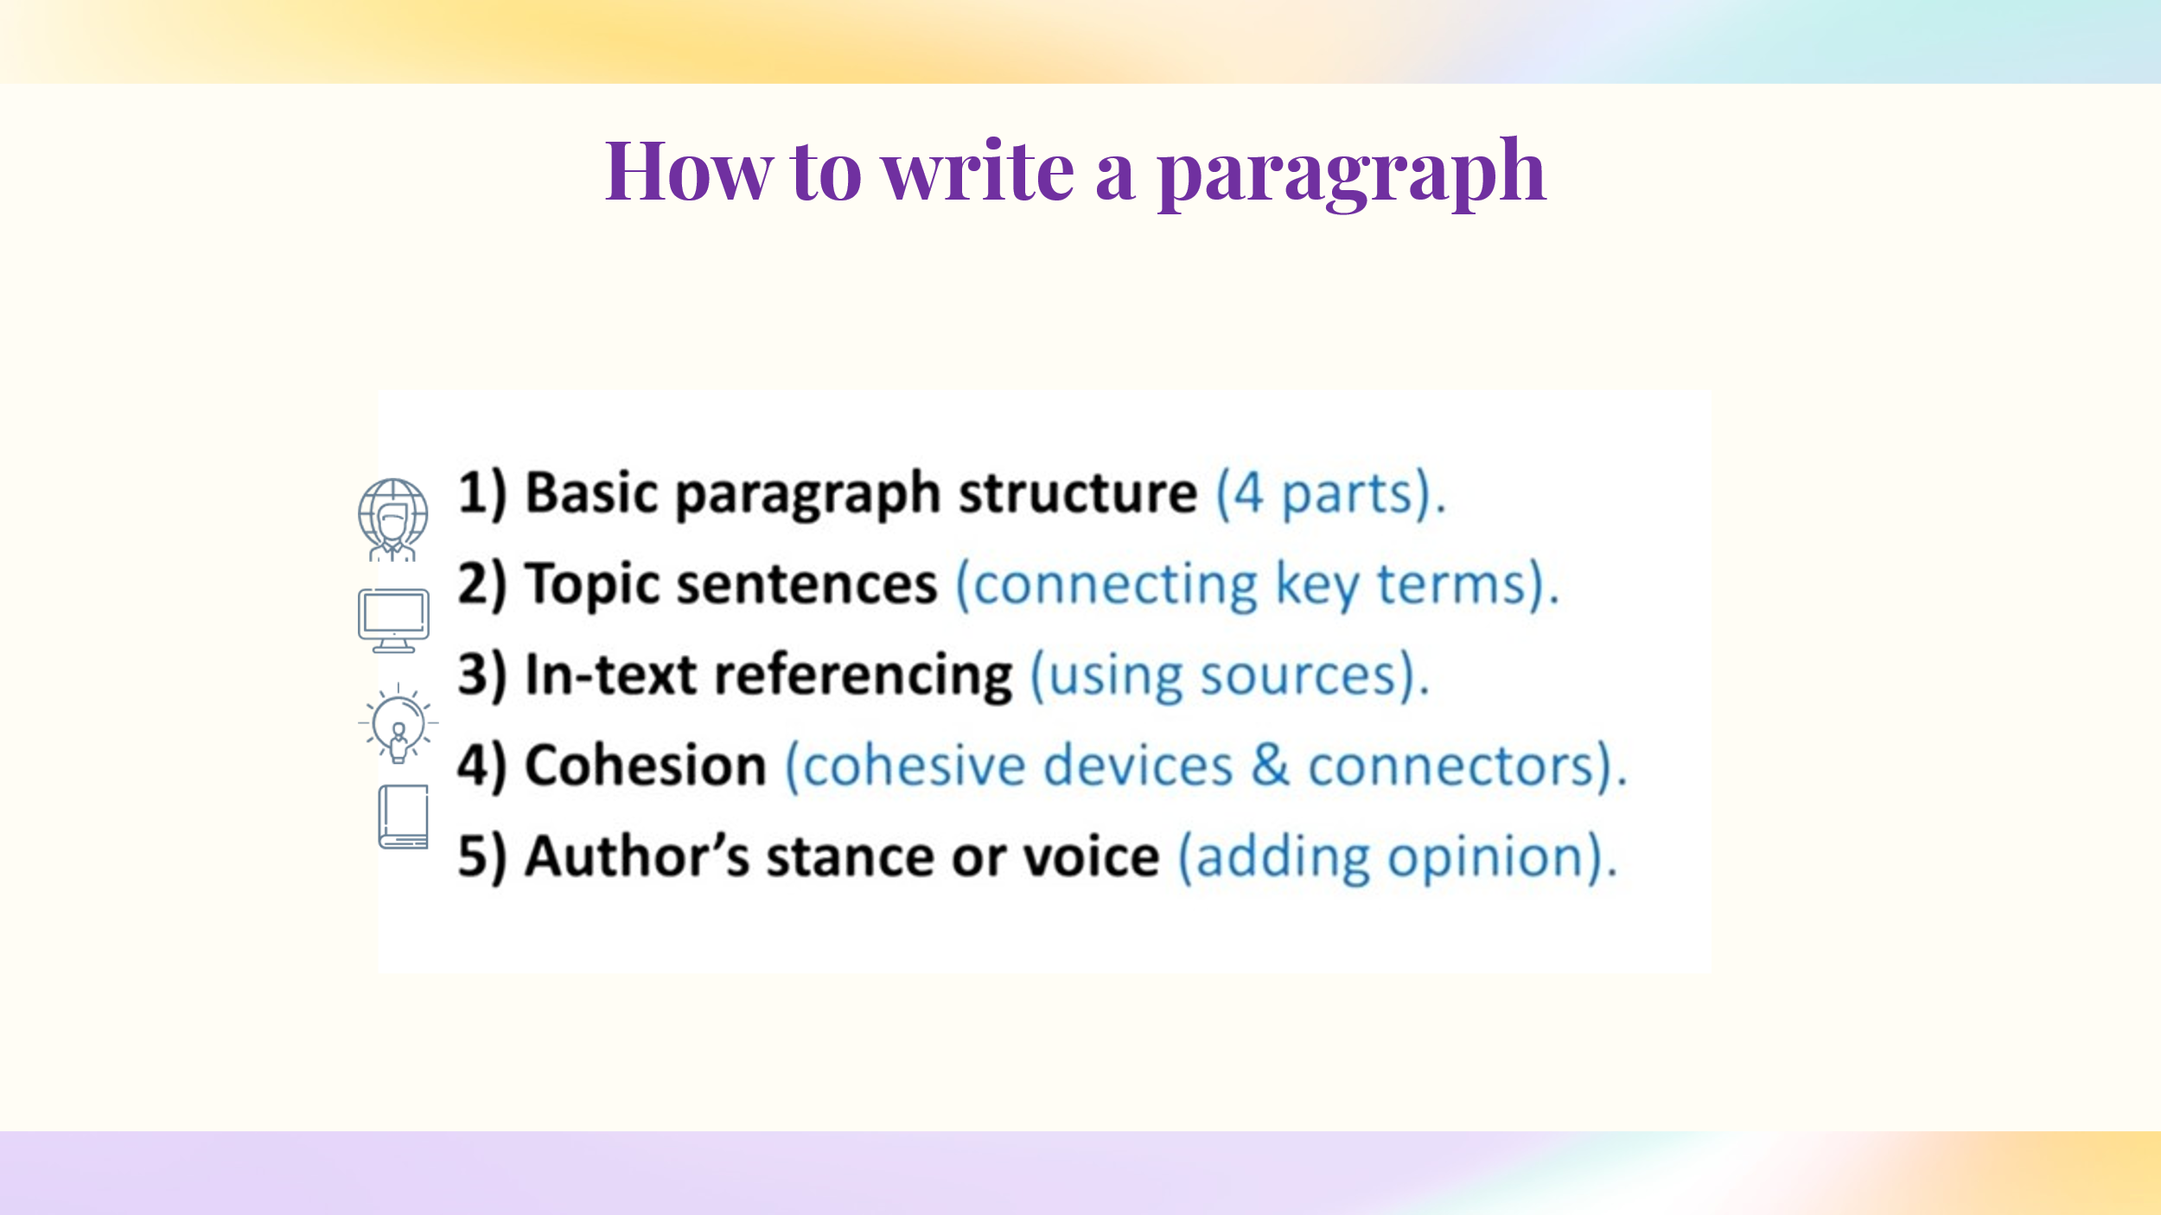  Let’s begin with a basic paragraph structure. Generally, a paragraph consists of four key parts or sections. The first section is the topic sentence, which identifies the key topic in the paragraph. The second section is development, where the main idea or topic is discussed in more detail. The third section is the example, which includes support, evidence, data, or statistics that validate your development. Finally, the fourth section is the summary, which encapsulates the overall main point.  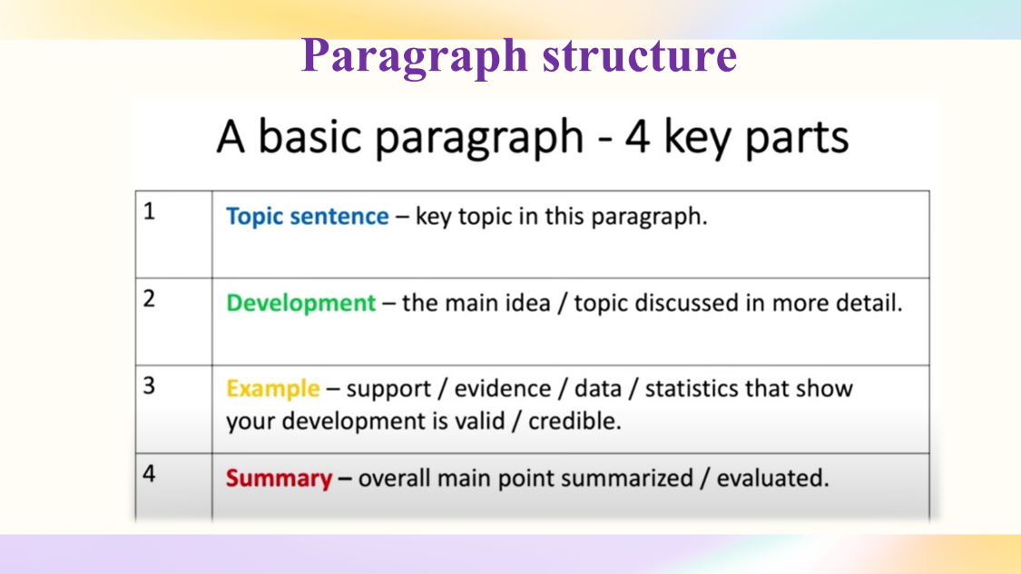  Of course, paragraphs can include many more parts like definitions, perspectives, analysis, and evaluation, but at a basic level, this is your foundation. Today will analyze a basic paragraph to help you understand the fundamentals of paragraph construction. Here is an academic paragraph on the topic of “The Big Mac index: where to buy a cheap hamburger”. Read the paragraph and identify the four key sections: the topic sentence, development, example, and summary
Students | In small groups students read the paragraph and identify 4 key parts. Then they report back on their findings.  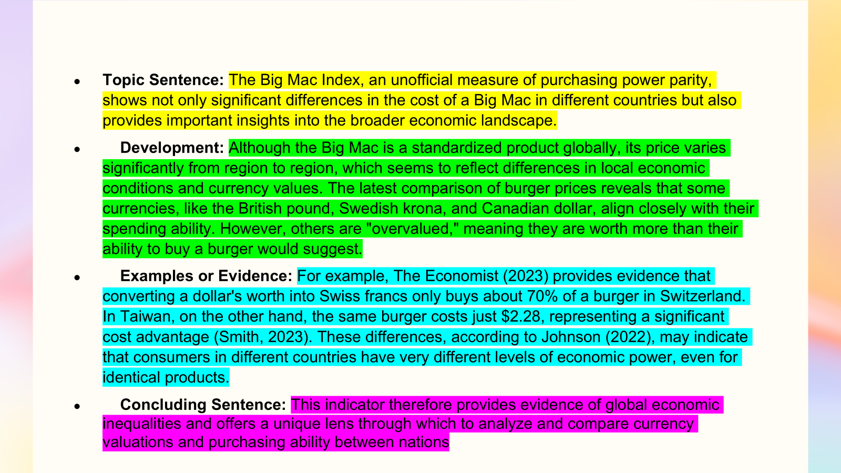
Teacher | Now, we’ll look at the topic sentence and its role in the paragraph.  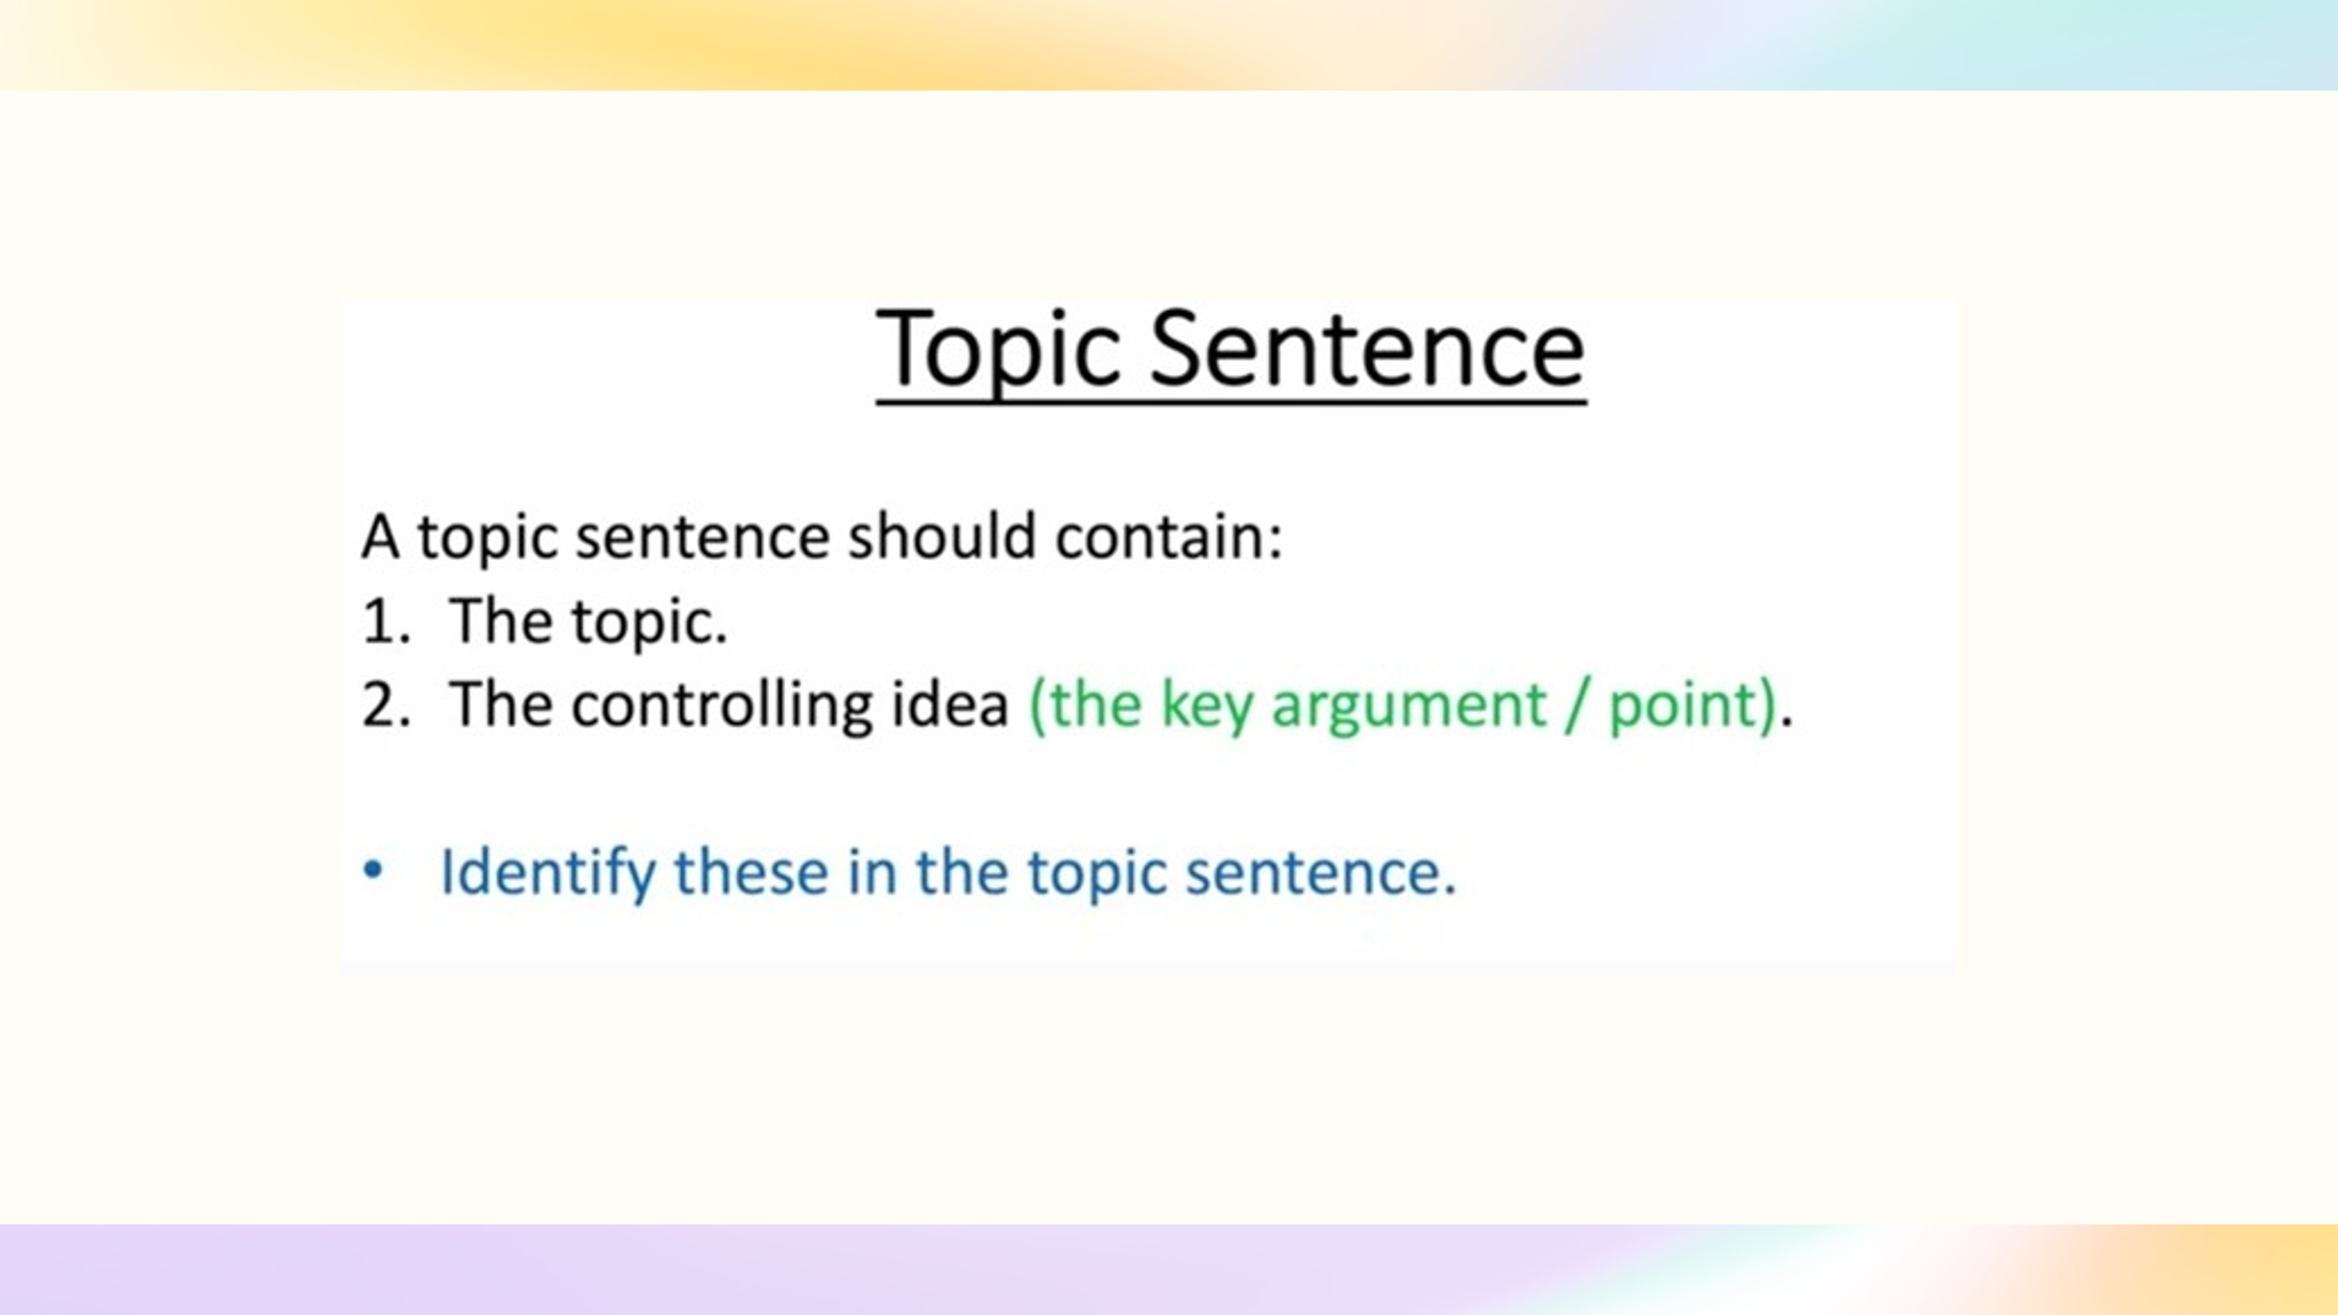  A topic sentence should contain the topic and the controlling idea (the key argument or point). Identify these elements in the topic sentence.
Students | In small groups students read the topic sentence and identify the topic and the controlling idea. Then they report back on their findings.  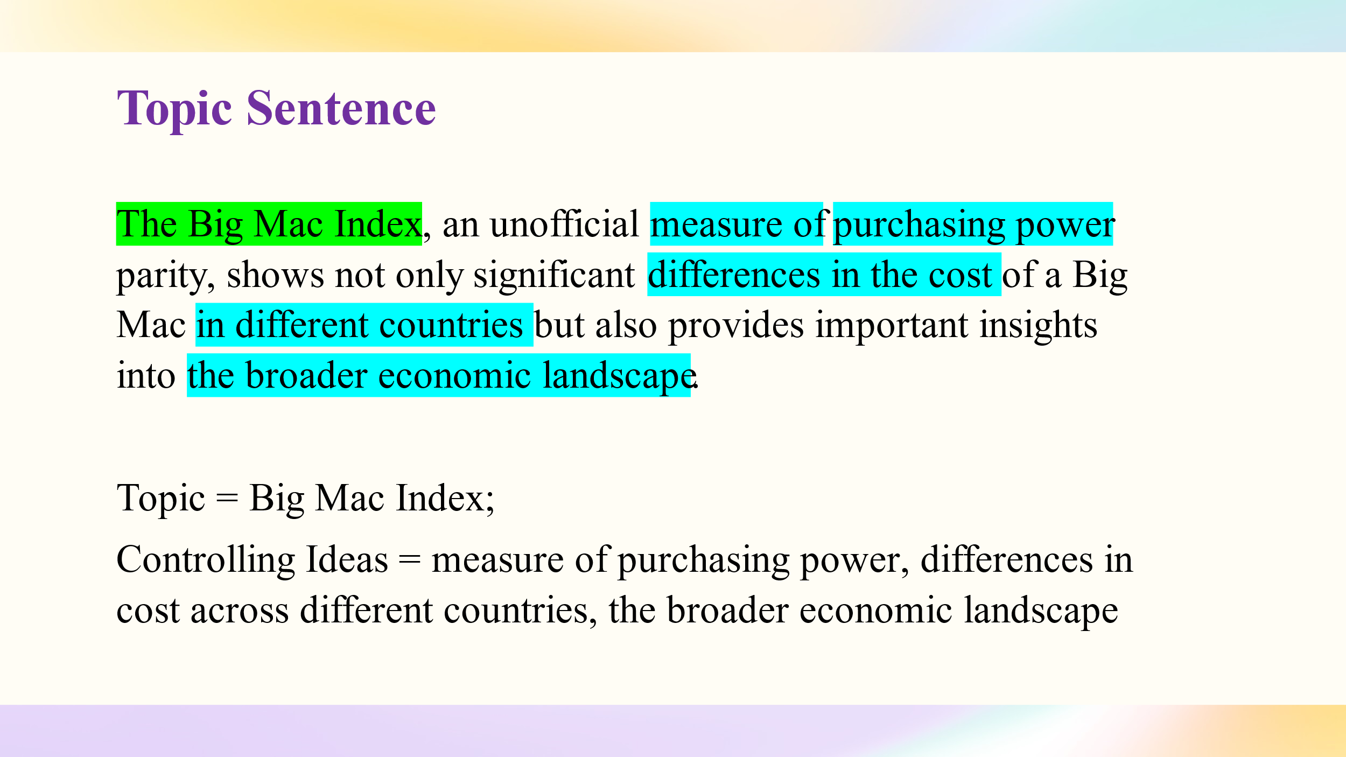  Students use Smart LMS for interactive practice and reinforcement of material.  Topic sentence https://edu.hse.ru/mod/quiz/view.php?id=1541115
Teacher | The paragraph should clearly connect to the topic sentence. There are four key connecting terms in the topic sentence that should be present in the main body: The Big Mac Index, differences in the cost, purchasing power, and broader economic landscape.  I have used different colors to identify each connecting term. Try to identify the connecting terms in the main body of the paragraph. There are lots of connections. Let’s highlight a couple of examples. The term ‘differences in the cost’ connects to ‘its price varies,’ while ‘purchasing power’ links directly to ‘spending ability,’ and ‘the broader economic landscape’ connects with ‘global economic inequalities.’  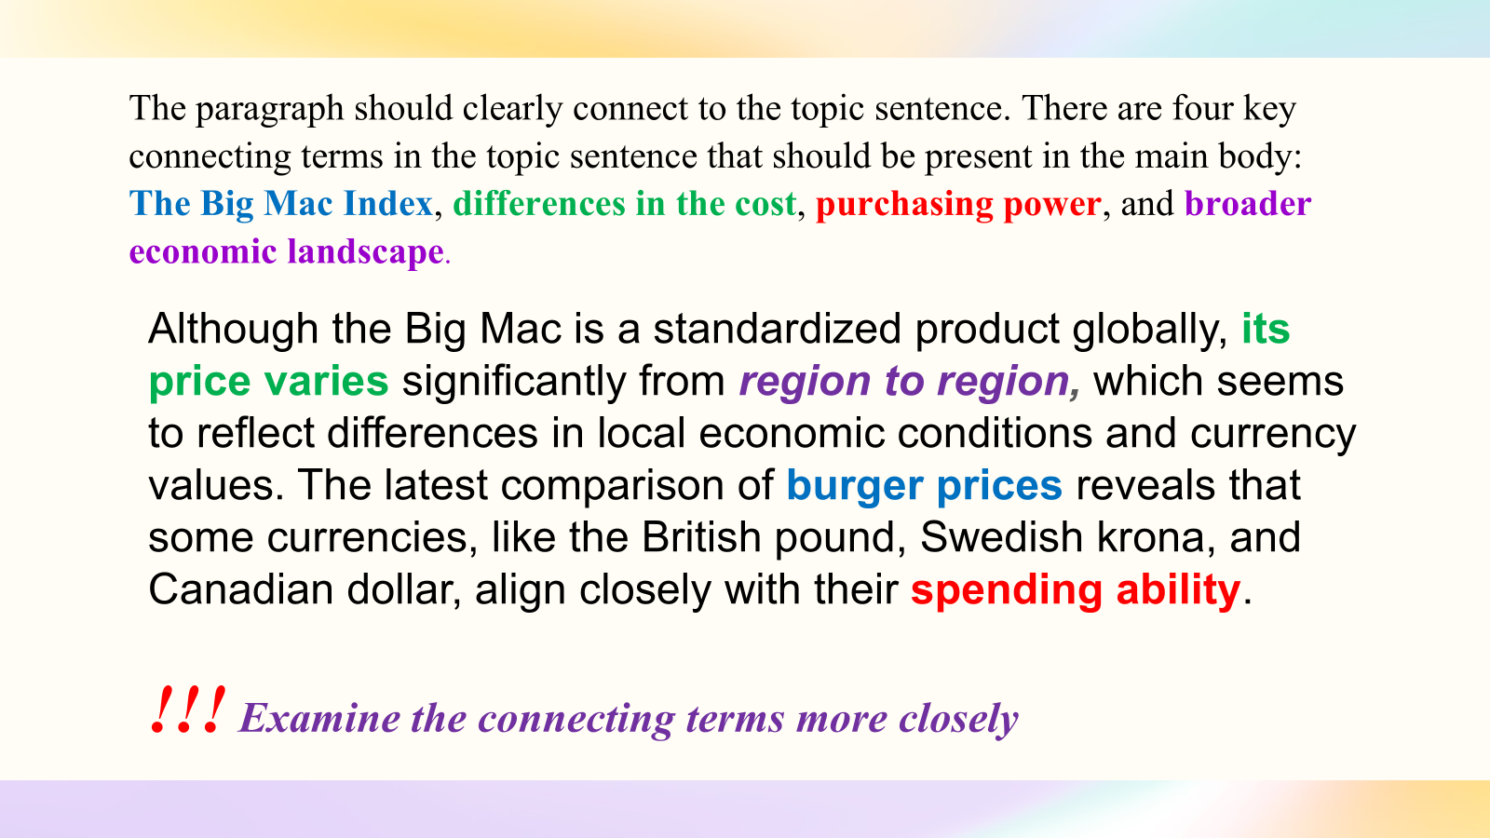
Students | In small groups students read the paragraph and examine the connecting terms more closely. Then they report back on their findings.  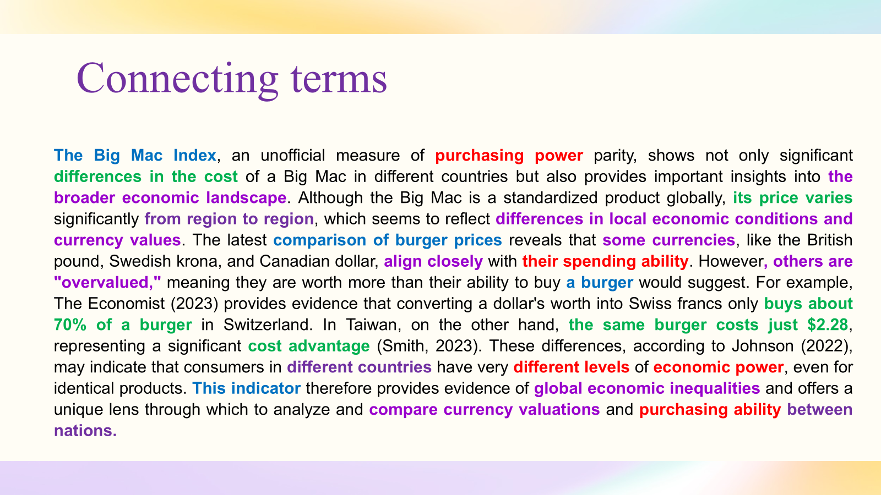
Teacher | Next point is intext referencing. Academic paragraphs contain sources to support the author’s ideas.  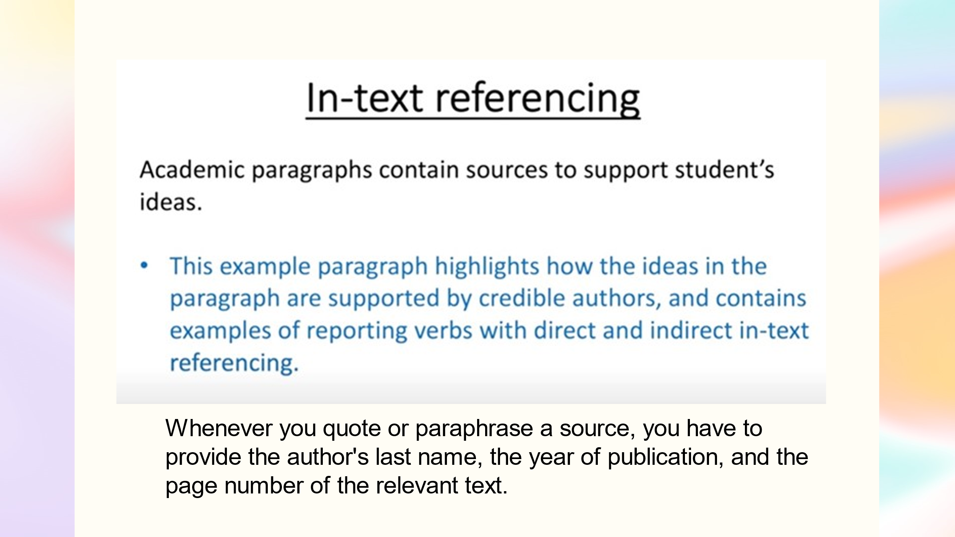  This paragraph highlights how the ideas are supported by credible authors and includes examples of reporting verbs with direct and indirect intext referencing. Highlight the intext references and reporting verbs.
Students | In small groups students read the paragraph and highlight the intext references and reporting verbs. Then they report back on their findings.  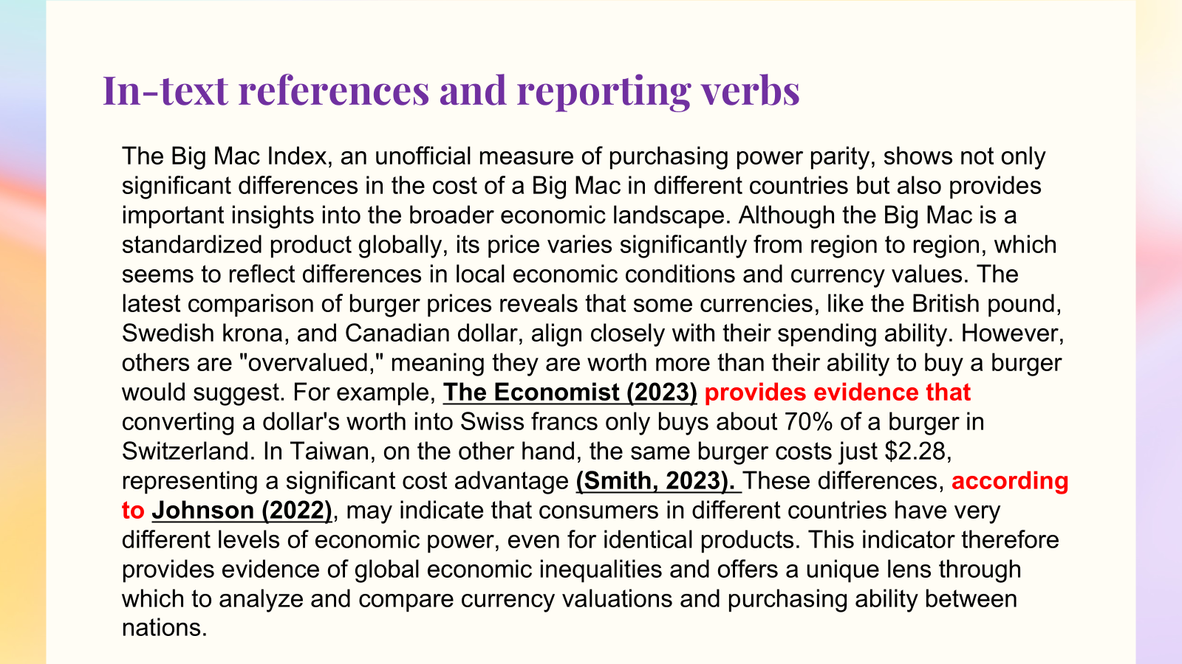
Teacher | The teacher summarizes the findings:  There are three key sources, The Economist, 2023; Smith, 2023; Johnson, 2022. The reporting verbs used include ‘according to’ / according to Johnson (2022), ‘provides evidence that’/ The Economist (2023) provides evidence that, and Smith, 2023 as an indirect reference.  Students use Smart LMS for interactive practice and reinforcement of material.  Referencing https://edu.hse.ru/mod/quiz/view.php?id=1541122  Reporting verbs https://edu.hse.ru/mod/quiz/view.php?id=1541752  Now, let’s move on to Cohesion.  Cohesion refers to how texts use grammar and vocabulary to connect ideas. This is done through pronouns, determiners, relative clauses, and connectors. Examples include ‘however’ as a linking phrase to show a contrast, ‘on the other hand’ as a linking phrase to introduce a point that is different from or opposite to the previous one, ‘for example’ as a linking word etc.  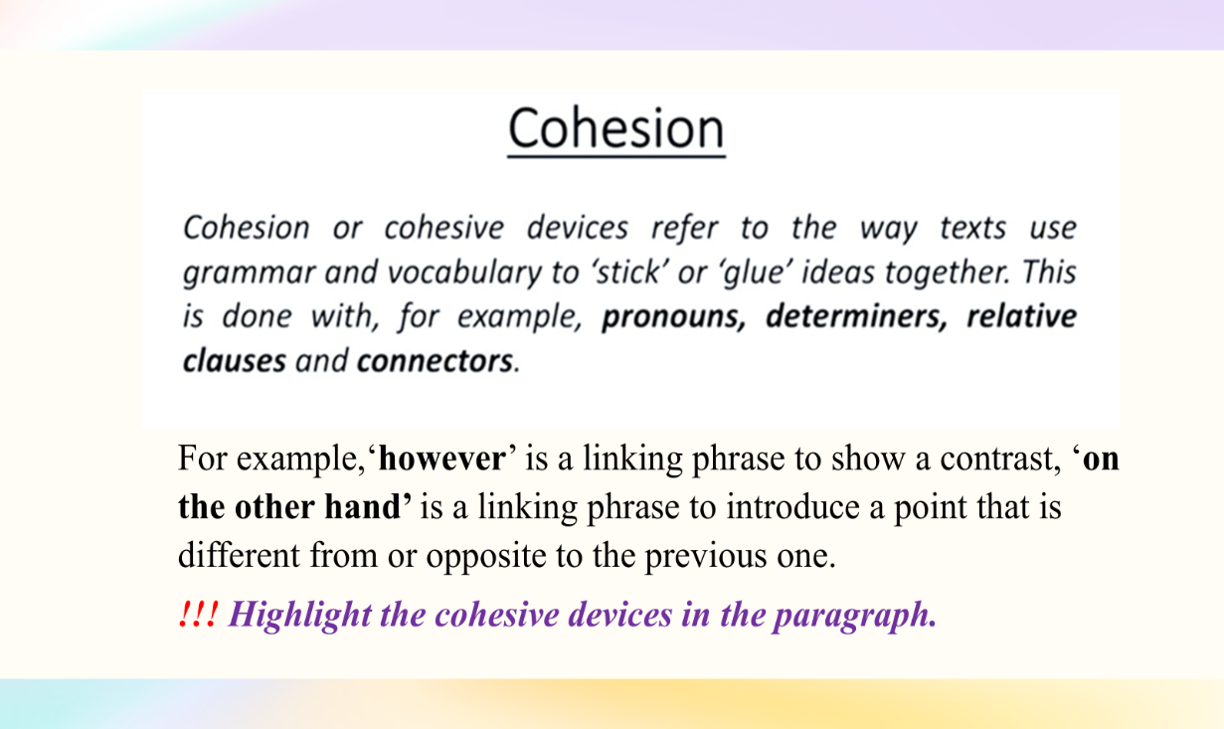
Students | In small groups students read the paragraph and highlight the cohesive devices in the paragraph. Then they report back on their findings.  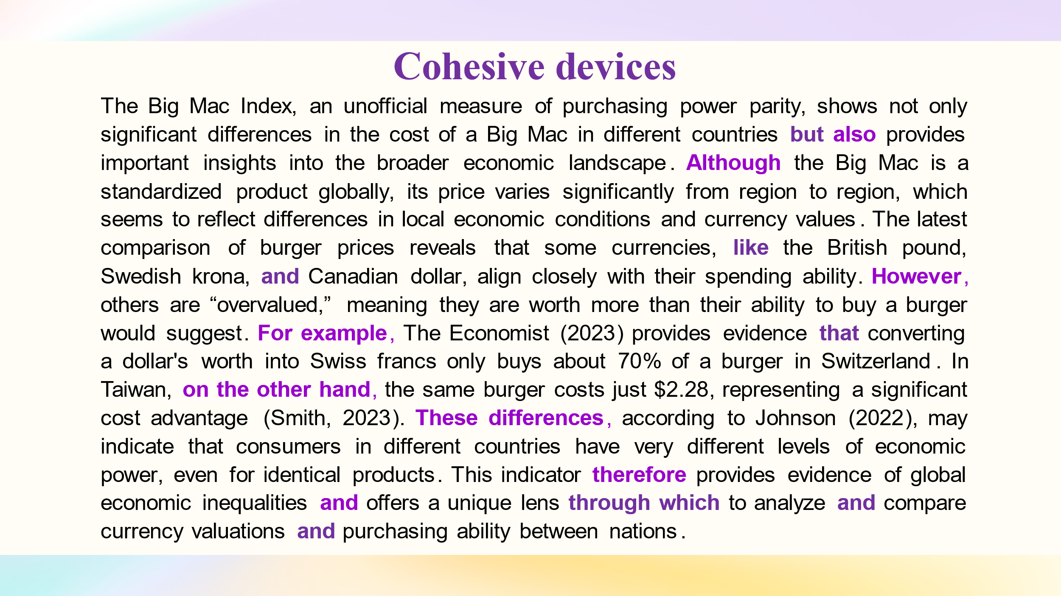  Students use Smart LMS for interactive practice and reinforcement of material.  Linking Words https://edu.hse.ru/mod/quiz/view.php?id=1565447
Teacher | This brings us to our final section: the author’s stance.  This is important as it is where the author expresses their opinion using language such as adjectives (significant, potential, important), verbs (may, can, could, seems to, tends to, claims, argues), adverbs (very, systematically, considerably, precisely), and evaluation phrases (fails to acknowledge, provides substantial evidence, a fundamental flaw).  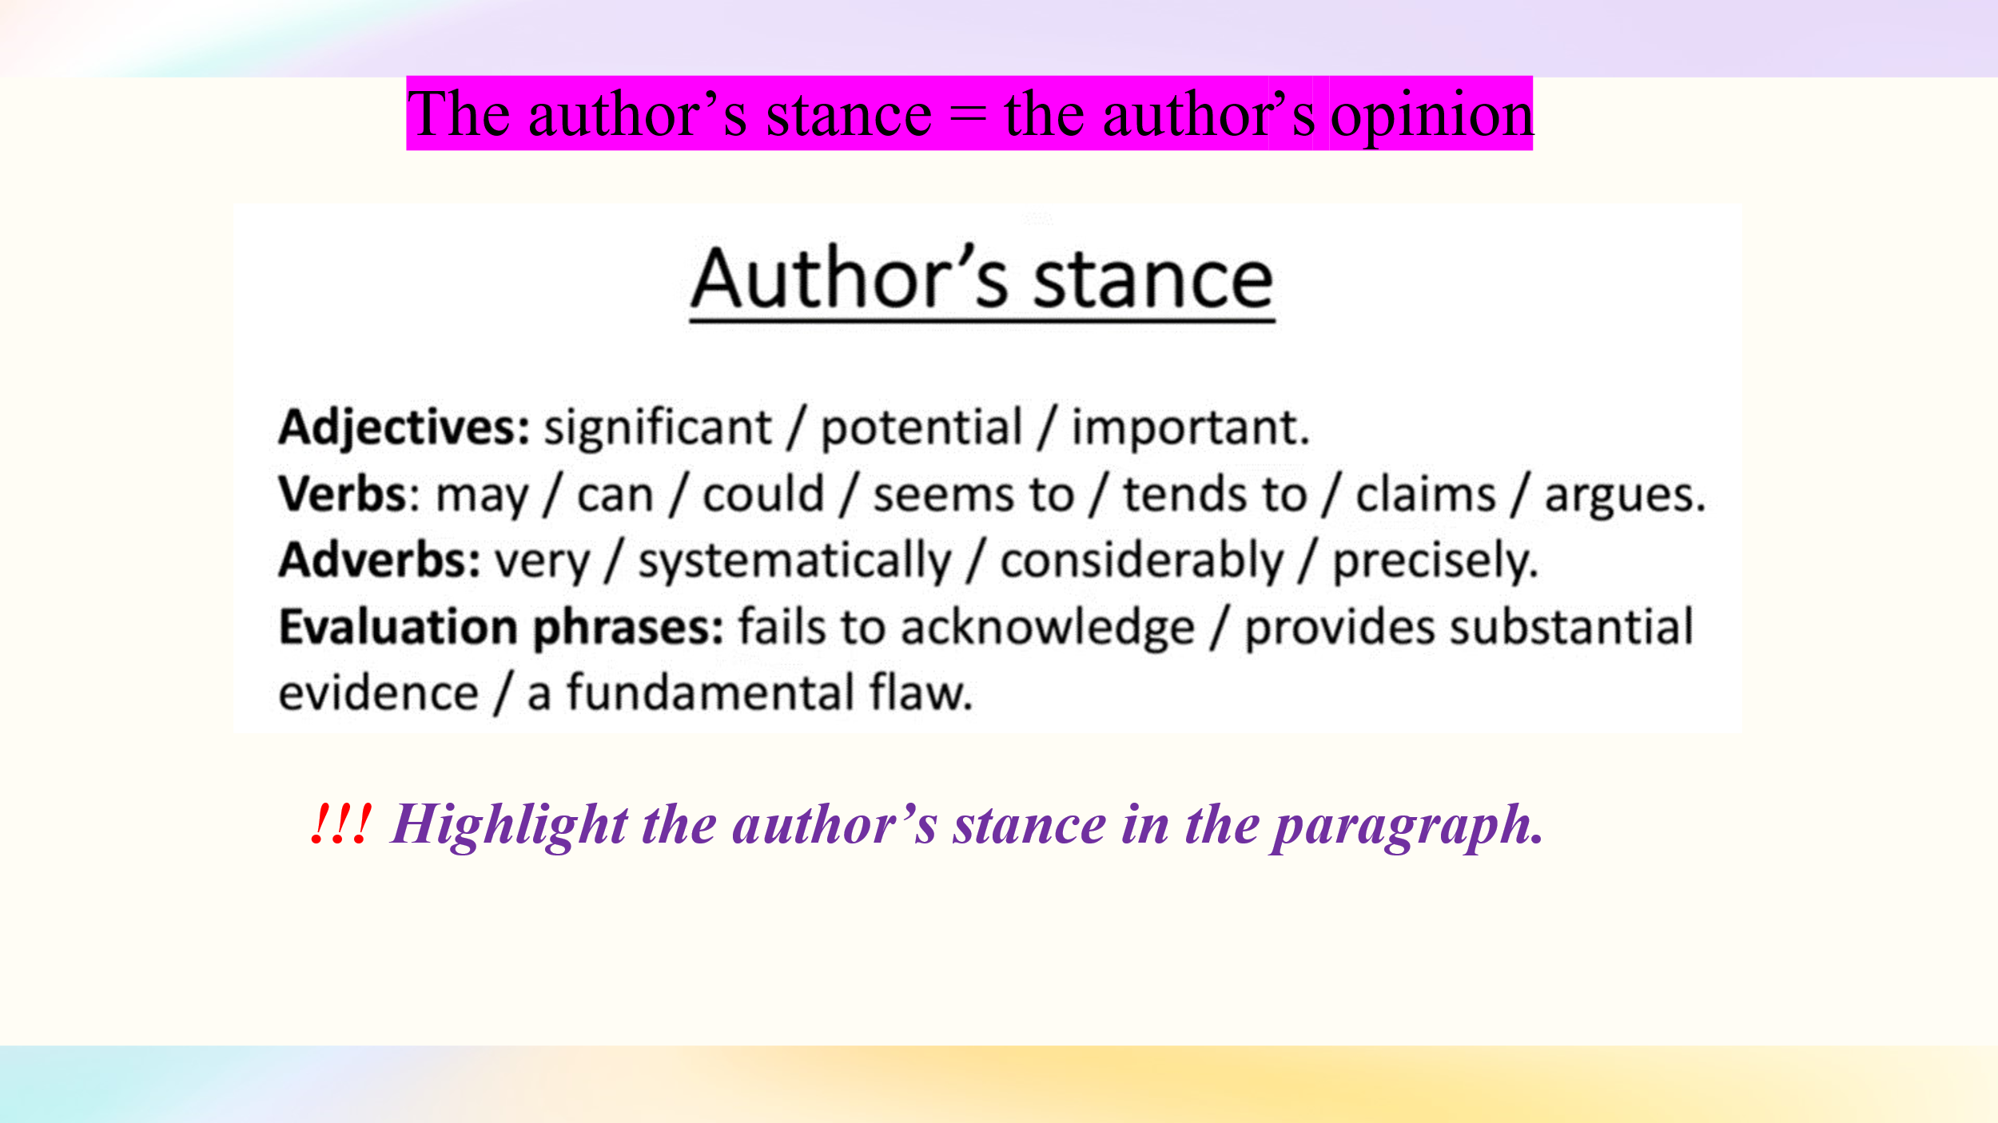  Highlight the author’s stance in the paragraph.
Students | In small groups students read the paragraph and highlight the author’s stance. Then they report back on their findings.  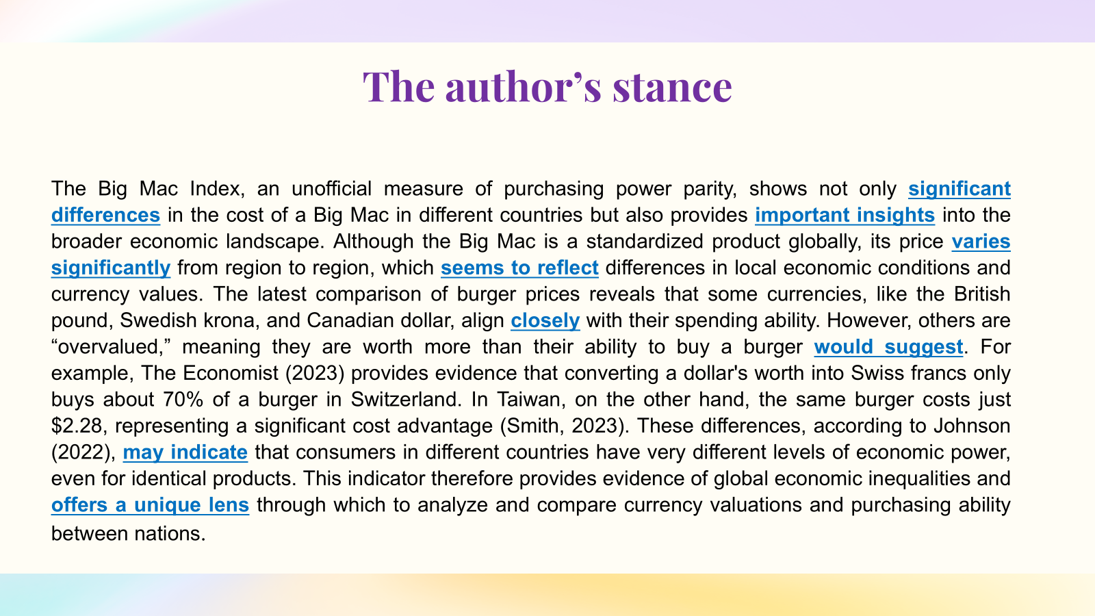  Students use Smart LMS for interactive practice and reinforcement of material.  Hedging https://edu.hse.ru/mod/quiz/view.php?id=1568681
Teacher | REVISION  Now with your partner review the key strategies for writing a paragraph and answer the following questions:  1) Is there a topic sentence? What is the topic? What is/are the controlling ideas?  2) Is there a main argument?  3) Which quotes were used?  4) Is it logical and clear? How has the paragraph been organised?  5) Is there an example?  6) Is there a concluding sentence? What is concluded?  7) How are the sources incorporated?
Students | REVISION  The Big Mac Index, an unofficial measure of purchasing power parity, shows not only significant differences in the cost of a Big Mac in different countries but also provides important insights into the broader economic landscape. (Topic = Big Mac Index; Controlling Idea = significant differences in cost and insights into the economic landscape)  Although the Big Mac is a standardized product globally, its price varies significantly from region to region, which seems to reflect differences in local economic conditions and currency values. (Development: Connecting Key Terms = Big Mac, standardized product, price variation, local economic conditions, currency values, Cohesion =Although; Author’s Stance = seems)  The latest comparison of burger prices reveals that some currencies, like the British pound, Swedish krona, and Canadian dollar, align closely with their spending ability. However, others are "overvalued," meaning they are worth more than their ability to buy a burger would suggest. (Examples or Evidence: Comparison of currencies = British pound, Swedish krona, Canadian dollar; Evidence of overvalued currencies, Cohesion = However; Author’s Stance = would suggest)  For example, The Economist (2023) provides evidence that converting a dollar's worth into Swiss francs only buys about 70% of a burger in Switzerland. In Taiwan, on the other hand, the same burger costs just $2.28, representing a significant cost advantage (Smith, 2023). (In-text Referencing = The Economist, 2023, Smith, 2023; Reporting Verbs = provides evidence, representing, Cohesion = For example, on the other hand)  These differences, according to Johnson (2022), may indicate that consumers in different countries have very different levels of economic power, even for identical products. (Reporting Verbs & the author’s Stance = may indicate; Key Terms = consumers, different levels of economic power)  This indicator therefore provides evidence of global economic inequalities and offers a unique lens through which to analyze and compare currency valuations and purchasing ability between nations. (Cohesive Devices = therefore, and; Key Terms = global economic inequalities, currency valuations, purchasing ability; Author’s Stance = unique)  The Big Mac Index is not only an interesting comparison of burger prices but also a valuable tool for understanding broader economic trends. (Author's Voice and Stance: interesting comparison, valuable tool, understanding economic trends; Author’s Stance = valuable, interesting)
Step II.
Paragraph Writing

Notes | This task is consolidation and practice. Students write an academic paragraph on The Impact of E-commerce on Traditional Retail Sales using the knowledge gained. Writing time is 30 minutes.
Individualized Task | As students have different levels of proficiency in the English language the teacher individualized writing task to assign work that matches each student’s current abilities, and to create a more inclusive and effective learning environment. This approach not only addresses the diverse needs of students but also fosters personal growth, engagement, and confidence in their language skills.  Instructions for Lower-Level Students  - Read the information about the impact of E-commerce on Traditional Retail Sales  - global ecommerce sales reached $5.7 trillion in 2022, accounting for 19.7% of total retail sales /Statista, 2023/  - brick-and-mortar stores saw a 10% decrease in foot traffic as a result of the rise in online shopping /The National Retail Federation, 2023 (a report)/  - 45% of consumers prefer online shopping due to convenience and better pricing, impacting traditional retail sales /Bern, 2022/  - Choose your stance. Decide if you think the rise of e-commerce represents a significant threat to traditional retail sales (negative stance) or if it offers opportunities for adaptation and growth within the retail sector (positive stance).  - Write a paragraph (130-150 words).  - Include the following elements in your paragraph:  In-text citations. Include the source of your information, for example, Brick-and-mortar stores experienced a 10% decrease in foot traffic due to the rise in online shopping, according to a report by the National Retail Federation (2023).  Hedging language. Use phrases such as “might,” “could,” “seem to,” or “may” to show uncertainty  Cohesive devices. Use phrases such as “For example,” to give an example; “As a result,” to show an effect; “However,” to show contrast; “Furthermore,” to emphasize an additional point.  Reporting verbs. Use reporting verbs to indicate the source of the information, for example, “claim,” “suggest,” “argue,” or “highlight” to convey the authors' positions.  - Use the following paragraph structure:  Topic sentence. Start with a definitive statement about e-commerce implications for traditional retail sales  Development. Provide a nuanced discussion that explores various dimensions of your argument.  Example. Integrate relevant statistics or examples to support your points.  Summary. Conclude with a synthesis of your main argument, reflecting on the broader implications.  Instructions for Intermediate Students  1. Analyze the information about the impact of E-commerce on Traditional Retail Sales  - global ecommerce sales reached $5.7 trillion in 2022, accounting for 19.7% of total retail sales /Statista, 2023/  - brick-and-mortar stores saw a 10% decrease in foot traffic as a result of the rise in online shopping /The National Retail Federation, 2023 (a report)/  - 45% of consumers prefer online shopping due to convenience and better pricing, impacting traditional retail sales /Bern, 2022/  2. Choose your stance. Decide if you think the rise of e-commerce represents a significant threat to traditional retail sales (negative stance) or if it offers opportunities for adaptation and growth within the retail sector (positive stance).  3. Write a paragraph (130-150 words).  4. Include the following elements in your paragraph: in-text citations, hedging language, cohesive devices, reporting verbs.  5. Use the following paragraph structure:  - Topic sentence  - Development  - Example  - Summary  Instructions for Advanced Students  1. Analyze the information about the impact of E-commerce on Traditional Retail Sales  - global ecommerce sales reached $5.7 trillion in 2022, accounting for 19.7% of total retail sales /Statista, 2023/  - brick-and-mortar stores saw a 10% decrease in foot traffic as a result of the rise in online shopping /The National Retail Federation, 2023 (a report)/  - 45% of consumers prefer online shopping due to convenience and better pricing, impacting traditional retail sales /Bern, 2022/  2. Formulate your argument. Critically assess whether the rise of e-commerce represents a significant threat to traditional retail sales (negative stance) or if it offers opportunities for adaptation and growth within the retail sector (positive stance).  3. Write a paragraph (130-150 words).
Students | Students write a paragraph on The Impact of E-commerce on Traditional Retail Sales.
Step III. Peer Feedback

Notes |   When the time allotted for writing a paragraph is over, students should exchange their papers and analyze them using a Peer feedback form. This form should guide the peer reviewer in providing specific and detailed feedback on the paragraph. Students have 20 minutes to review their peer’s paragraph.
Teacher | Read your partner’s paragraph carefully. Use this checklist to identify key strategies in their writing. Provide constructive feedback to help them improve their writing.  Students read their partners’ paragraphs and fill in the checklist. Доска Miro
Peer Feedback Checklist

Criteria | Score | Peer notes
1. Paragraph structure
Has your partner clearly organized the paragraph with the following elements: Topic Sentence Development Examples or Evidence, references, Concluding Sentence? | 1
Is the main idea discussed in detail? | 1
2. Topic and controlling idea
Has your partner effectively identified the topic and controlling idea in the topic sentence? | 1
Are the key terms connected throughout the paragraph? | 1
3. Intext referencing and reporting verbs
Has your partner included appropriate intext references to support their points? | 1
Are reporting verbs used to indicate the stance of the references? | 1
4. Cohesive Devices:
Has your partner used cohesive devices (e.g., conjunctions, transitions) to link ideas smoothly? | 1
Do these devices enhance the flow of the paragraph? | 1
5. Author’s voice and stance:
Has your partner clearly expressed their own voice and stance on the topic? | 1
Is their opinion reflected through adjectives, verbs, adverbs, and evaluative phrases? | 1
6. Final Rating max.10
Overall, how effectively does the paragraph meet the criteria listed above? Provide a score out of 10.
7. General Comments
What suggestions do you have for improvement?

Students | Then in pairs they provide their feedback.  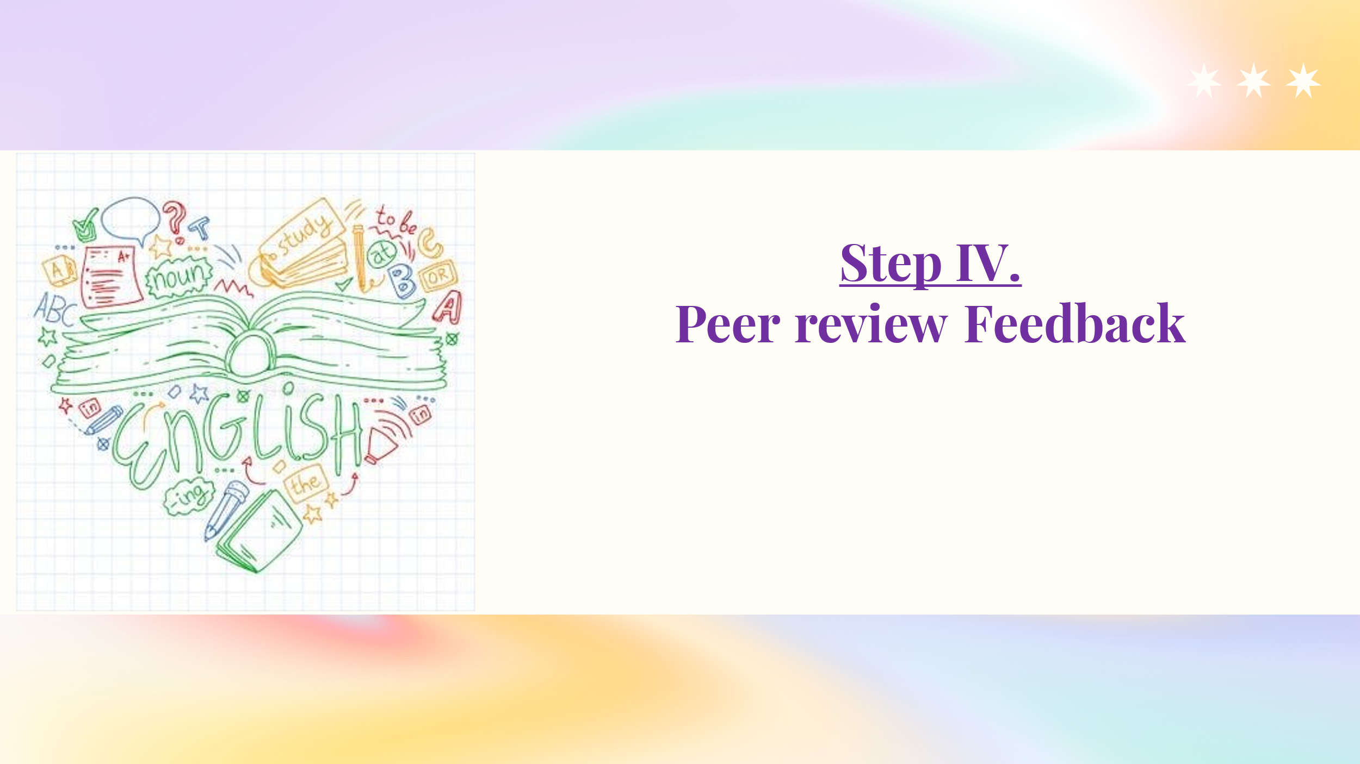
Step V.
Improvements based on the peer feedback

Notes | Students should improve their paragraphs taking into account the reviewer's recommendations and submit their papers for final assessment.  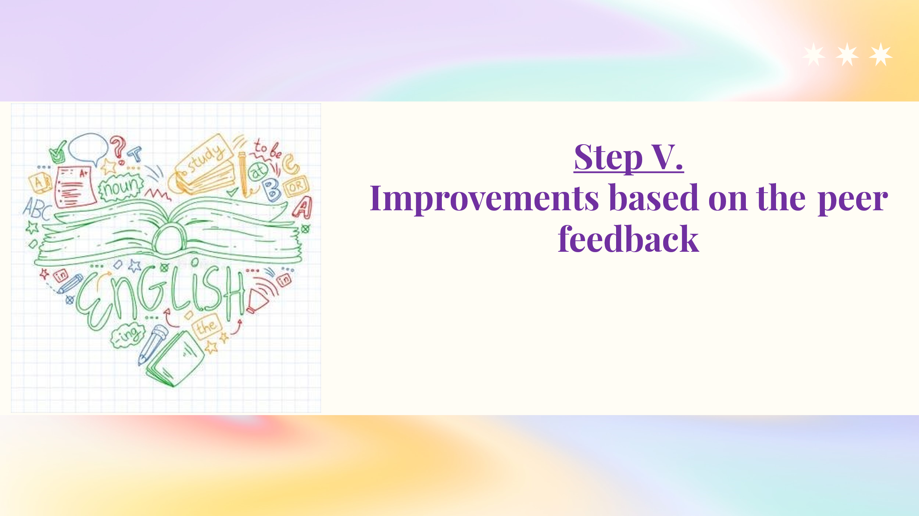
Teacher | The teacher grades the improved paragraphs.

Оценка эффективности методики
Для подтверждения эффективности данной методики мы провели эксперимент, в котором на добровольной основе принимали участие две группы студентов 4 курса бакалавриата НИУ ВШЭ, обучавшихся по направлению Бизнес-информатика. В первой группе (n=10) были студенты, изучавшие тему Mastering the Art of Writing an Academic Paragraph в курсе академического письма, во второй (n=8) – не изучавшие данную тему. Студентам дали задание - написать параграф (130-150 слов) на тему “The impact of inflation on small business profit margins”, используя следующие ссылки на источники:
- 58% of small businesses experienced a significant reduction in profit margins due to rising inflation
/The U.S. Small Business Administration, 2022/
- inflation in 2022→ a 15% increase in operational costs for small businesses
/A study by McKinsey & Company, 2023/
- 72% of small business owners are concerned about the long-term impact of inflation on their profitability
/a survey by the National Federation of Independent Business, 2023/
В качестве примера для анализа были выбраны два параграфа, получившие самые высокие оценки в каждой группе. Paragraph I написан студентом из первой группы, Paragraph II – студентом из второй группы.
Paragraph I | Paragraph II
The impact of inflation on the profit margins of small businesses is a significant concern that can affect their sustainability. Rising inflation leads to increased operational costs that small businesses often struggle to absorb. For example, a study by McKinsey & Company (2023) found that there was a substantial 15% increase in operating costs for small businesses in 2022 caused by inflation. Moreover, the U.S. Small Business Administration (2022) claims that 58% of small businesses experienced a significant reduction in their profit margins due to these rising costs. According to a survey by the National Federation of Independent Business (2023), 72% of small business owners are worried about the long-term impact of inflation on their ability to sustain their profits. Thus, it seems clear that inflation poses a significant threat to the financial health of small businesses. Failure to address these challenges could lead to serious consequences for the viability of small businesses. (153 words) | Inflation significantly affects the profit margins of small businesses, making it challenging for them to sustain profitability. As inflation increases, many small businesses find it difficult to manage the rising operational costs. For example, inflation led to a 15% increase in operational costs for small businesses in 2022. This financial burden is further strengthened by concerns among small business owners about the long-term effects of inflation. According to a survey by the National Federation of Independent Business (2023), 72% of small business owners worry about the impact of inflation on their profitability. If these challenges are not effectively addressed, small businesses may face difficulties in maintaining their operations and ensuring long-term sustainability.  (120 words)

Затем мы сравнили два параграфа по каждому из критериев, обозначенных форме оценивания.
 | Paragraph I | Paragraph II
1. Paragraph structure | The paragraph is clearly organized with a topic sentence, detailed development, examples, references (McKinsey & Company, U.S. Small Business Administration, National Federation of Independent Business), and a concluding sentence that summarizes the potential impact of inflation on small businesses | The paragraph is well-structured with a clear topic sentence, development, examples, references, and a concluding sentence. However, it is slightly less detailed compared to Paragraph I.
 | Score: 2/2 | Score: 1.5/2
2. Topic and Controlling Idea | The topic ("The impact of inflation on small businesses") and the controlling idea (how inflation affects profit margins) are clearly identified in the topic sentence. Key terms such as "inflation," "profit margins," and "small businesses" are consistently referenced throughout the paragraph. | The topic and controlling idea are effectively identified, and key terms like “inflation” and “profit margins” are consistently connected. However, fewer examples are given compared to the first paragraph.
 | Score: 2/2 | Score: 1.5/2
3. Intext referencing and reporting verbs | The paragraph includes appropriate intext references, supported by sources. Reporting verbs like "found" and "claims" are used to present data objectively. | The paragraph uses appropriate intext references and reporting verbs, such as “According to a survey,” but includes fewer references than Paragraph I. The reference to the source “National Federation of Independent Business (2023)” is not included.
 | Score: 2/2 | Score: 1/2
4. Cohesive Devices | Cohesive devices such as "moreover," "for example," and "thus" effectively link ideas, ensuring smooth flow between sentences. | Cohesive devices like “for example” and “this financial burden” are used to connect ideas, but the paragraph lacks more varied transitions, making it slightly less smooth
 | Score: 2/2 | Score: 1.5/2
5. Author’s Voice and Stance: | The author's stance is clear, emphasizing the seriousness of inflation's impact on small businesses. Evaluative phrases like "significant concern" and "serious consequences" convey the author's opinion | The author's voice is present, but the evaluative language is less forceful than in Paragraph 1. The stance is expressed through phrases like "may face difficulties," but it could be stronger.
 | Score: 2/2 | Score: 1.5/2
6. General Comments | This paragraph is well-structured and informative, with strong supporting evidence. To improve, the author could enhance the final sentence by suggesting specific measures small businesses could take to address inflation. | This paragraph is clear and well-structured but could benefit from more detailed evidence and stronger transitions. Strengthening the author's stance with more evaluative language would improve the impact.
7. Final Rating | 10/10 | 7/10

Полученные результаты позволяют сделать вывод об эффективности внедряемой практики.
- Оценив работы всех студентов, мы сравнили средний балл, полученный за написание академического параграфа в двух выборках. В первой группе, принимавшей участие в практике Mastering the Art of Writing an Academic Paragraph, средний балл составил 7.5, тогда как во второй, обучавшейся по традиционной методике, — 6.2. Таким образом, студенты, прошедшие обучение с применением целевой методики, продемонстрировали более высокие результаты, что свидетельствует о её положительном влиянии на развитие навыков академического письма.
- В марте 2025 года был также проведён сравнительный анализ оценок за более комплексное письменное задание — Project Proposal. Средний балл студентов, обучавшихся по внедряемой методике, составил 7.2, тогда как в контрольной группе, работавшей по традиционному учебному плану, — 6.8. Полученные результаты подтверждают устойчивость положительного эффекта предлагаемого подхода при выполнении заданий более высокого уровня сложности.
- В рамках последующего анкетирования обучающихся было выявлено, что 88% респондентов отметили улучшение содержания и структуры Project Proposal благодаря организации взаимной обратной связи и рекомендациям, полученным от одногруппников. Студенты также подчеркнули, что эти советы способствовали повышению качества проектной работы.
Совокупность приведённых данных может служить эмпирическим обоснованием эффективности разработанной методики в процессе формирования академических и проектных компетенций обучающихся.

Изменения, внесённые в материал, обозначены с помощью зелёного выделения для удобства отслеживания.

